1. CREATE DATABASE
MongoDB Query:
use Students
Explanation: Creates or switches to the Student database.

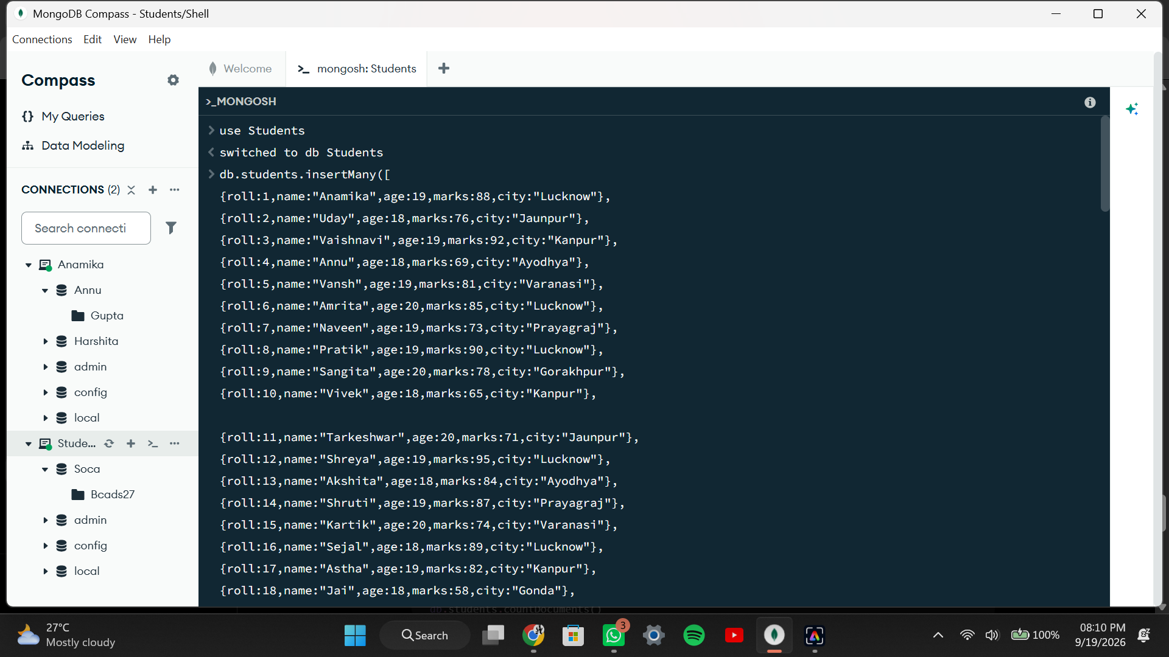

2. CREATE COLLECTION
MongoDB Query:
db. create Collection("students")
Explanation: Creates a collection named students.
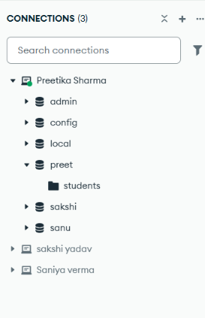
3. INSERT 50 STUDENTS
MongoDB Query:
db. students. Insert Many([ ])
{roll:1, name:"Anamika", age:19,marks:88,city:"Lucknow"},
{roll:2, name:"Uday", age:18,marks:76,city:"Jaunpur"},
{roll:3, name:"Vaishnavi", age:19,marks:92,city:"Kanpur"},
{roll:4, name:"Annu", age:18,marks:69,city:"Ayodhya"},
{roll:5, name:"Vansh", age:19,marks:81,city:"Varanasi"},
{roll:6, name:"Amrita", age:20,marks:85,city:"Lucknow"},
{roll:7, name:"Naveen", age:19,marks:73,city:"Prayagraj"},
{roll:8, name:"Pratik", age:19,marks:90,city:"Lucknow"},
{roll:9, name:"Sangita", age:20,marks:78,city:"Gorakhpur"},
{roll:10, name:"Vivek", age:18,marks:65,city:"Kanpur"},
{roll:11, name:"Tarkeshwar", age:20,marks:71,city:"Jaunpur"},
{roll:12, name:"Shreya", age:19,marks:95,city:"Lucknow"},
{roll:13, name:"Akshita", age:18,marks:84,city:"Ayodhya"},
{roll:14, name:"Shruti", age:19,marks:87,city:"Prayagraj"},
{roll:15, name:"Kartik", age:20,marks:74,city:"Varanasi"},
{roll:16, name:"Sejal", age:18,marks:89,city:"Lucknow"},
{roll:17, name:"Astha", age:19,marks:82,city:"Kanpur"},
{roll:18, name:"Jai", age:18,marks:58,city:"Gonda"},
{roll:19, name:"Harshita", age:20,marks:91,city:"Lucknow"},
{roll:20, name:"Omkar", age:19,marks:63,city:"Bareilly"},
{roll:21, name:"Ayush", age:18,marks:77,city:"Lucknow"},
{roll:22, name:"Saumya", age:19,marks:86,city:"Jaunpur"},
{roll:23, name:"Vidya", age:20,marks:72,city:"Kanpur"},
{roll:24, name: "Adarsh", age:19,marks:80,city:"Ayodhya"},
{roll:25, name: "Anmol", age:18,marks:67,city:"Prayagraj"},
{roll:26, name: "Anushka", age:20,marks:94,city:"Lucknow"},
{roll:27, name: "Ananya", age:19,marks:88,city:"Varanasi"},
{roll:28, name: "Bhaskar", age:18,marks:61,city:"Gorakhpur"},
{roll:29, name: "Rohan", age:19,marks:75,city:"Kanpur"},
{roll:30, name: "Nishant", age:20,marks:79,city:"Lucknow"},
{roll:31, name: "Vineet", age:18,marks:68,city:"Jaunpur"},
{roll:32, name: "Anika", age:19,marks:90,city:"Lucknow"},
{roll:33, name: "Jai", age:20,marks:55,city:"Ayodhya"},
{roll:34, name: "Lakshya", age:18,marks:83,city:"Kanpur"},
{roll:35, name: "Krishna", age:19,marks:96,city:"Prayagraj"},
{roll:36, name: "Rumana", age:20,marks:70,city:"Lucknow"},
{roll:37, name: "Priyanshu", age:18,marks:81,city:"Varanasi"},
{roll:38, name: "Aditya", age:19,marks:66,city:"Gorakhpur"},
{roll:39, name: "Dhruv", age:20,marks:93,city:"Lucknow"},
{roll:40, name: "Nivedita", age:19,marks:85,city:"Kanpur"},
{roll:41, name: "Meenu", age:18,marks:74,city:"Jaunpur"},
{roll:42, name: "Akanksha", age:20,marks:89,city:"Lucknow"},
{roll:43, name: "Sarika",age:19,marks:62,city:"Ayodhya"},
{roll:44, name: "Anchal",age:18,marks:78,city:"Prayagraj"},
{roll:45, name: "Umra", age:20,marks:84,city:"Lucknow"},
{roll:46, name: "Nashra", age:19,marks:73,city:"Kanpur"},
{roll:47, name: "Aman", age:18,marks:59,city:"Gonda"},
{roll:48, name: "Priya", age:20,marks:87,city:"Lucknow"},
{roll:49, name: "Rahul", age:19,marks:64,city:"Bareilly"},
{roll:50, name: "Neha", age:18,marks:91,city:"Varanasi"}
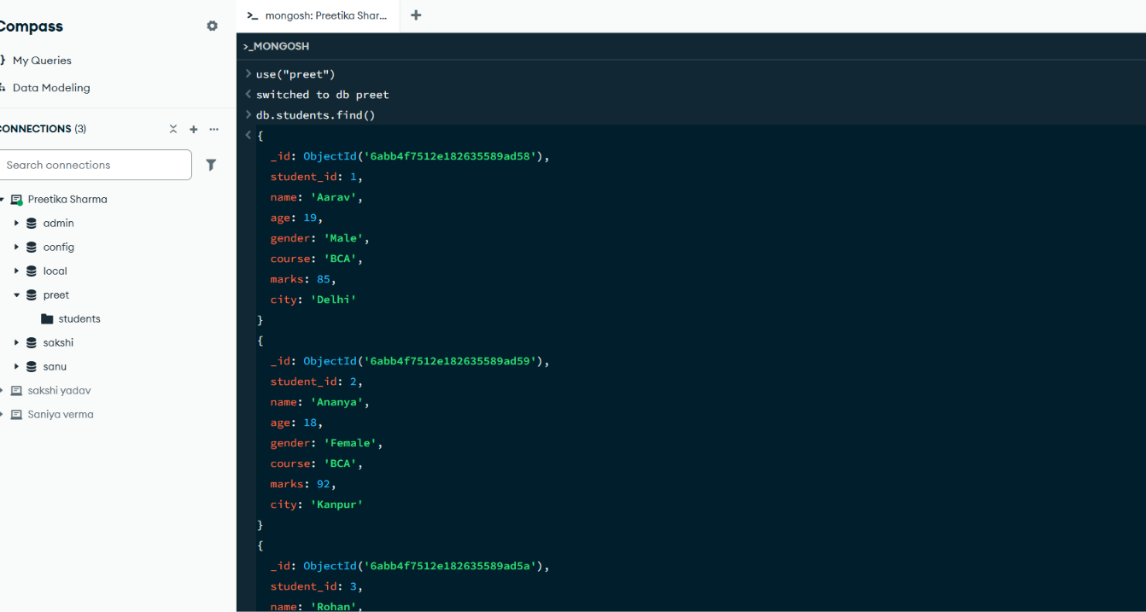
Explanation: Inserts multiple student documents into the collection.

4. DISPLAY ALL STUDENTS
MongoDB Query:
db. students. Find ()
Explanation: Retrieves documents from the students collection.
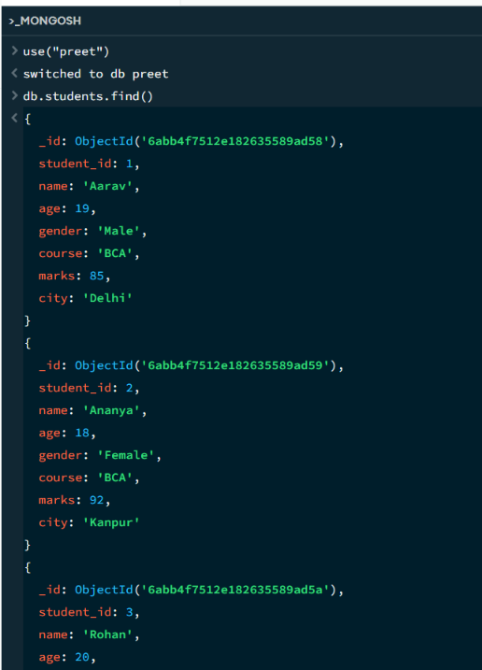
5. EQUAL TO — $eq
MongoDB Query:
db. students. Find ({marks: {$eq: 88}})
Explanation: Finds students whose marks are exactly 88.

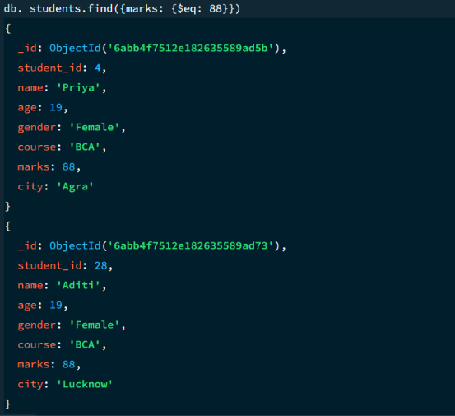
6. GREATER THAN — $gt
MongoDB Query:
db.students.find({marks: {$gt: 85}})
Explanation: Finds students whose marks are greater than 85.
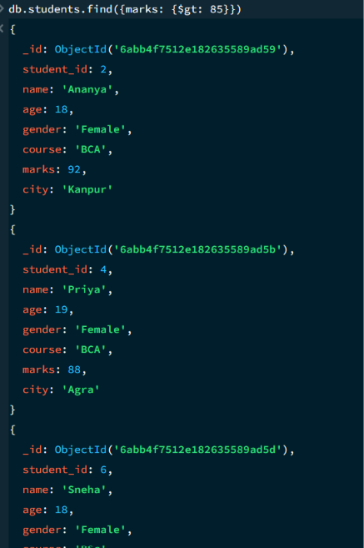

7. LESS THAN — $lt
MongoDB Query:
db. students. find ({marks: {$lt: 60}})
Explanation: Finds students whose marks are less than 60.

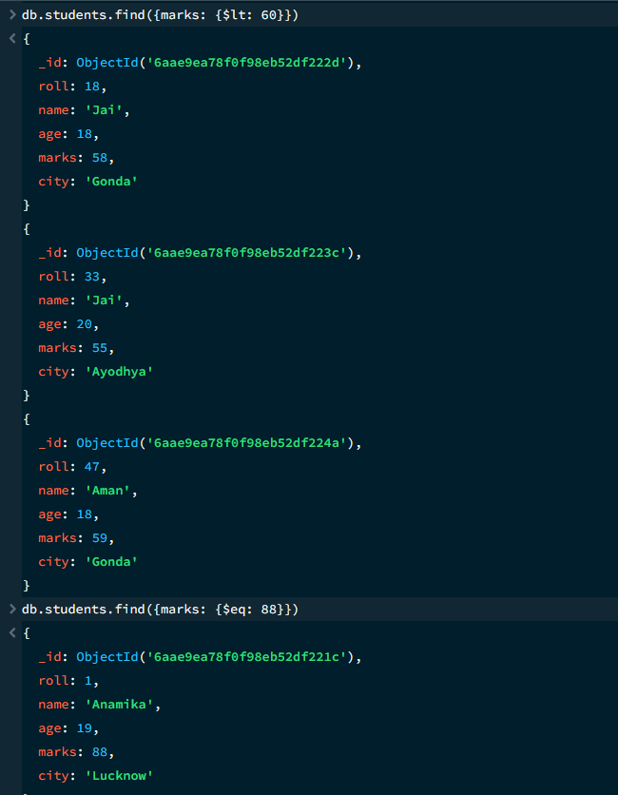
8. GREATER THAN OR EQUAL TO — $gte
MongoDB Query:
db. students. find({marks: {$gte: 90}})
Explanation: Finds students whose marks are 90 or above.

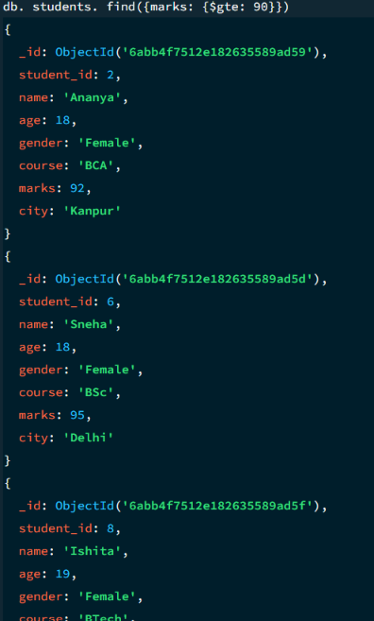

9. LESS THAN OR EQUAL TO — $lte
MongoDB Query:
db. students. find({marks: {$lte: 70}})
Explanation: Finds students whose marks are 70 or below.

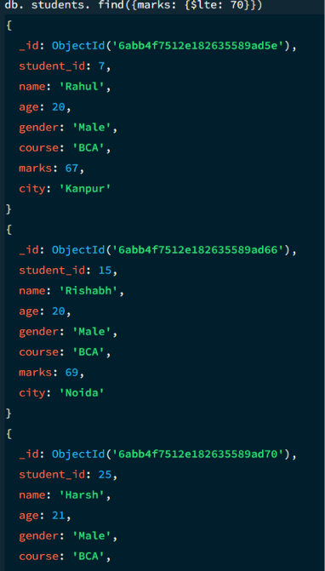

10. UPDATE OPERATION
MongoDB Query:
db.students.updateOne(
{student_id:5},
{$set:{marks:95}}
)
Explanation: Updates the marks to 95 of the student with student_id: 5.

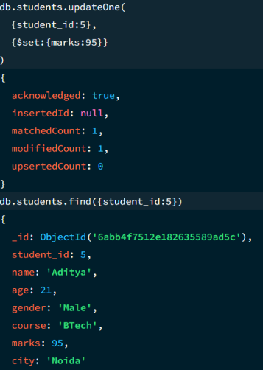

11. DELETE ONE OPERATION
MongoDB Query:
db.students.deleteOne({student_id:10})
Explanation: Deletes one document matching student_id 10.

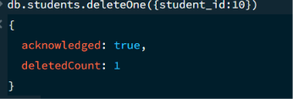

12. DELETE MANY OPERATION
MongoDB Query:
db.students.deleteMany({
marks: {$lt:95}
})
Explanation: Deletes all students having marks below 95.

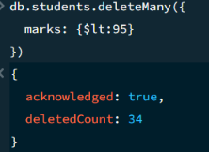

13. AND OPERATION — $and
MongoDB Query:
db. students. find({
$and:[
{marks:{$gt:80}},
{age:19}
]
})
Explanation: Finds students satisfying both conditions.
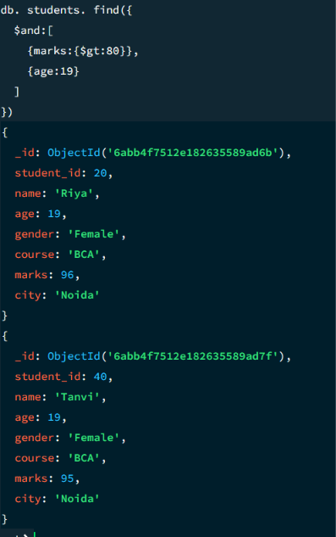

14. OR OPERATION — $or
MongoDB Query:
db.students.find({
$or:[
{city:"Delhi"},
{city:"Kanpur"}
]
})
Explanation: Finds students from Delhi or Kanpur.
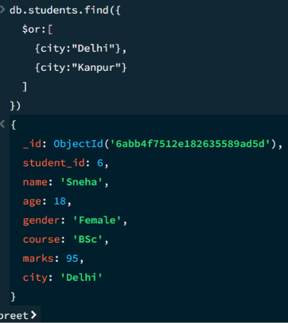

15. SORT OPERATION
A.MongoDB Query:
db. students. find (). sort({marks : 1})
Explanation: Sorts students by marks from lowest to highest. Use 1 for ascending order.
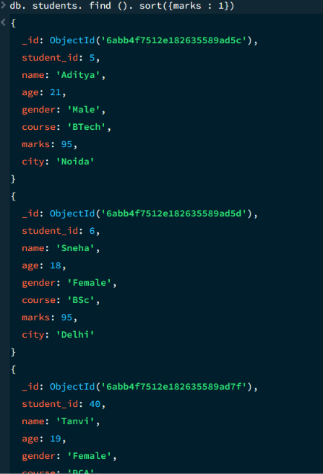

B. MongoDB Query:
db. students. find (). Sort ({marks: -1})
Explanation: Sorts students by marks from highest to lowest. Use -1 for descending order.
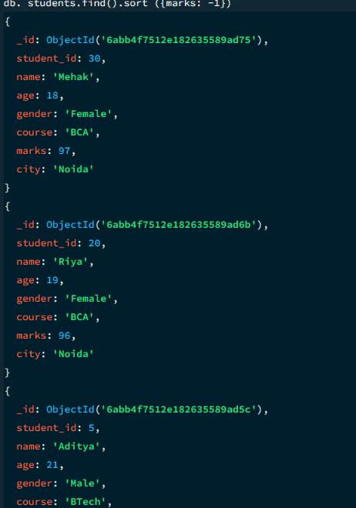
16. LIMIT OPERATION
MongoDB Query:
db. students. find (). limit (5)
Explanation: Displays only the first five documents.

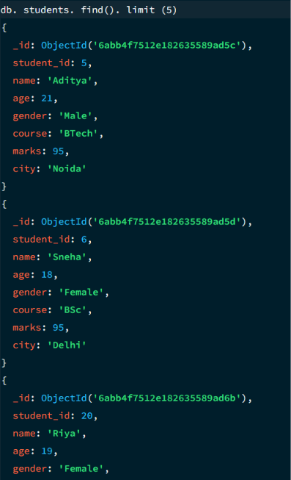

17. SEARCH BY CITY
MongoDB Query:
db.students.find({city:"Lucknow"})
Explanation: Finds all students whose city is Lucknow.
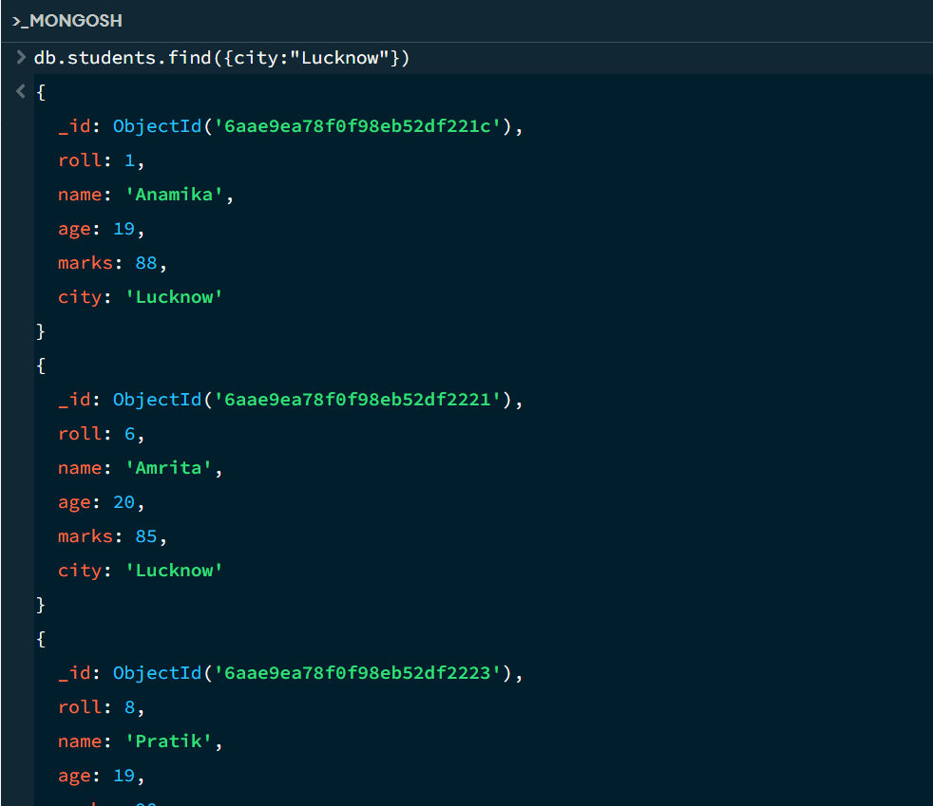

18. COUNT DOCUMENTS
MongoDB Query:
db. students. count Documents ()
Explanation: Counts documents currently present in the collection (performing after the delete function).
